Effects of Li evaporation/sputtering into the plasma:

- Plasma edge: impurity radiation
- Core: Bremsstrahlung (associated with higher Z_{eff}) A_{Li}=3 so the impact on Z_{eff} is low, can tolerate up to 10% He so maybe can tolerate similar amounts of Li. However, have to worry about fuel dilution.
- Fuel dilution get a fuel dilution of a factor or 3 (it takes 3 plasma electrons to support one Li neutral atom).

Difficult to put a limit on the vapor pressure.

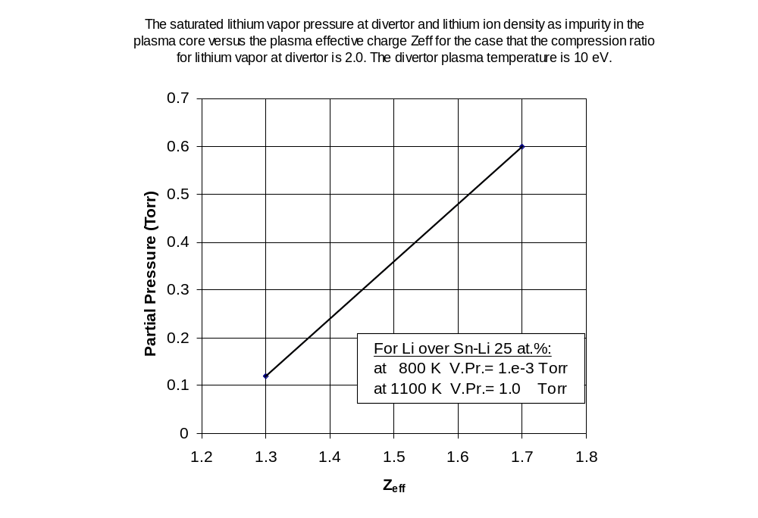

X. Zhou and M. S. Tillack, “Assessment of Liquid Metal as the Divertor Surface of a Fusion Power Plant,” UCSD-ENG-079, Jan. 1998.
